Washingtonville High School Alumni Association
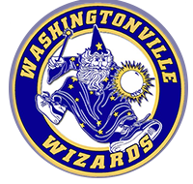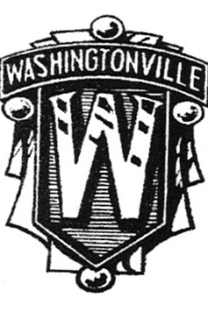
Multi Year Class Reunion
Saturday August 16, 2025
3 PM – 8 PM
Otterkill Country Club
100 Otter Road Campbell Hall NY 10916

 PLEASE SHARE REUNION INFORMATION WITH YOUR CLASSMATES. 
Menu
Crudites
Appetizers
Chicken
Penne
Asian Steak
Dessert
Coffee, tea
Soft drinks
Beer
Cash Bar for wine & liquor

(Dietary needs can be handled-let us know)

Tickets
$65 Per Person
Limited to 320
Visit here for payment


It has been three years since our last gathering at the Otterkill
The committee has worked hard to make our 2025 reunion a memorable one! Each class will have their own table where classmates can catch up and share memories of days gone by.
The proceeds from our reunions and alumni dues go to support the Alumni Scholarship awarded to a graduating child/grandchild of an alumnus
from Washingtonville High School.

The reunion is an informal event with seating inside and out.
TICKET PURCHASE DEADLINE – JULY 12!!
NO REFUNDS WILL BE GIVEN

Like us on Facebook: Washingtonville High School Alumni Association

Reservation For:
Name____________________________________________________________Class Year_________________
Address_____________________________________________________________________________________
Home #______________________________________Cell#___________________________________________
Email_______________________________________________________________________________________
Amount of Check$____________ Make payable to Washingtonville Alumni Association
Support the Scholarship Fund with your dues to the Alumni Association: 1 Year $10_____3 Years $25_____
MAIL WITH PAYMENT: Washingtonville Alumni Assoc. PO Box 38 Blooming Grove, NY 10914-0038 no later than
July 12.

